**Specification Document**

**FlyAway**

This project is developed by Kalviyarasi M

The source code is attached below

**Source code**:

<https://github.com/kalviyarasi/Practise_project/tree/master/Phase1-FlyAway>

**Sprint Planning**

This project is planned to complete within a week and divided into 3 sprints

Sprint 1: The outline of the project is designed-2 days

Sprint 2: Implementation part is executed -4 days

Sprint 3: Code is tested and bug fixation is done -1 day

**Core Concepts**

The concepts of creating Dynamic web project, JDBC, Hibernate, JSP, JSTL is used to implement the project.

**Algorithm**

**Step1:** create a dynamic web project in eclipse

**Step2:** create a package and class for the project

**Step3:** create a home page where Admin can login, user can login, new account can be created or user can directly enter into home page without creating account.

**Step4:** admin enter into admin page where admin can add new airline, new flight.

**Step5:** user login into home page and enter the source, destination, date.

**Step6:** if flight is available, then prompt to payment page.

**Step7:** the user can pay through credit card, debit card or UPI.

**Step8:** if paymentis successful, then it prompts to booking page.

**Step9:** logout the portal after successful completion of payment**.**

**Step10:** If needed, then can login again and book tickets.

**Demo of the project**

When the code is executed, it prompts to a window where it shows “Welcome to FlyAway Portal” as shown below.

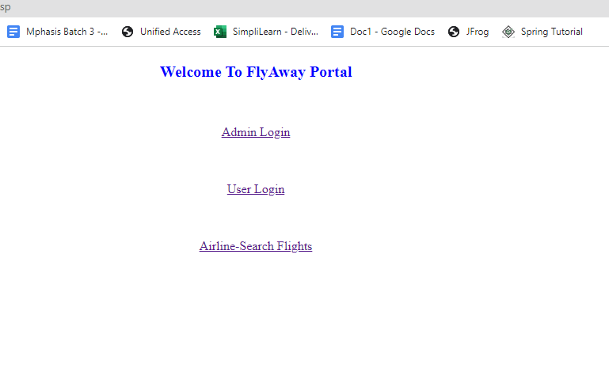

It displays 3 options:

* If admin, then can add new flight, change the password.
* If not a user, then can create a new account, login and get into home page.
* If user is not interested to create a new account,then can directly enter into home page to book tickets.

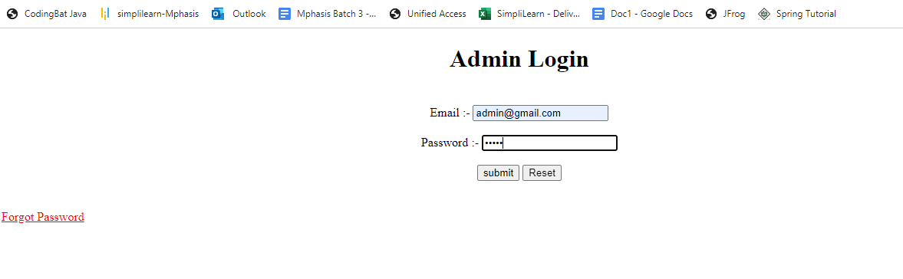

Admin can login using the credentials and go to admin page.

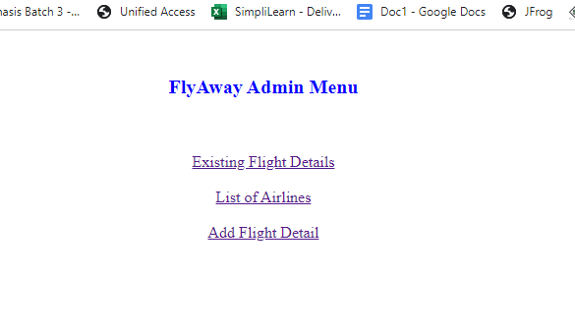

Admin can see existing flight details, list of airlines, add new flight details

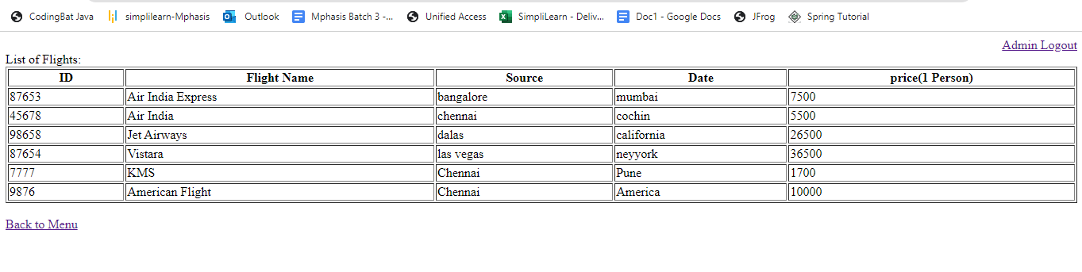

Here is the list of available flights. Admin can return to main menu if needed.

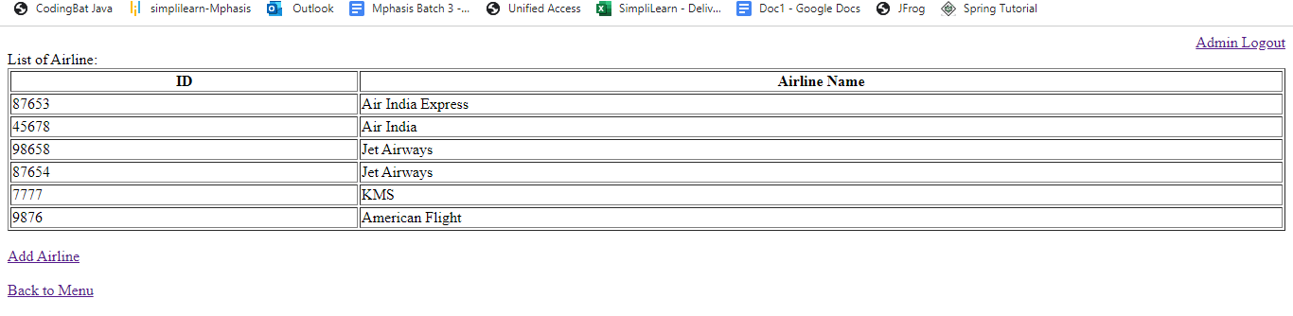

List of airlines can also be viewed by admin.

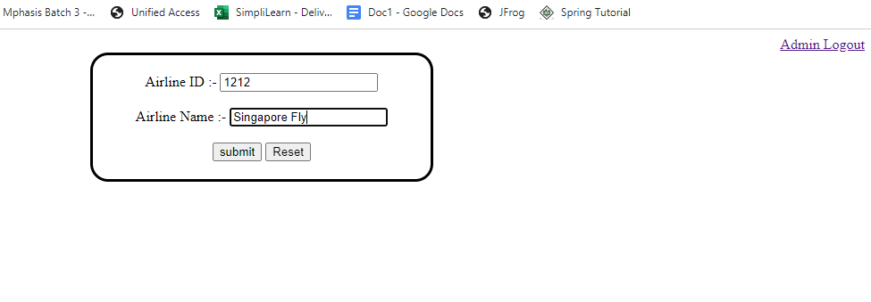

Admin can add new air line

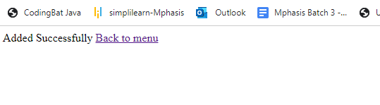

Once new airline is added successfully, it shows “Added Successfully”.

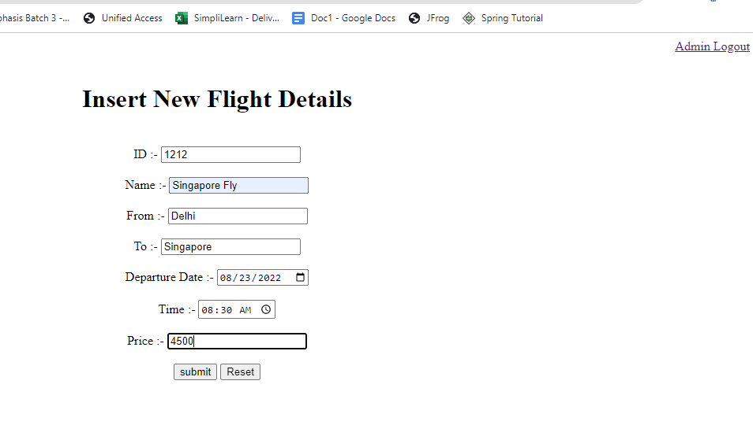

Admin can add new Flight Details

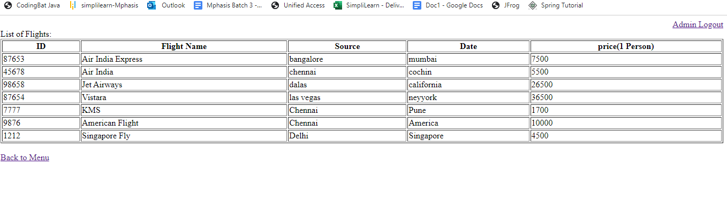

Here we could see the newly added flight details in the last column.

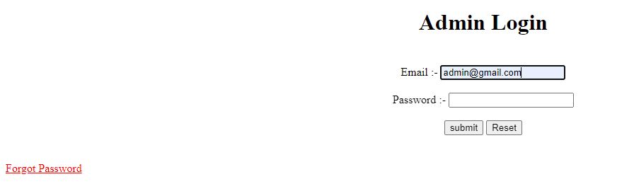

Admin can only change the password if needed or forgot the password

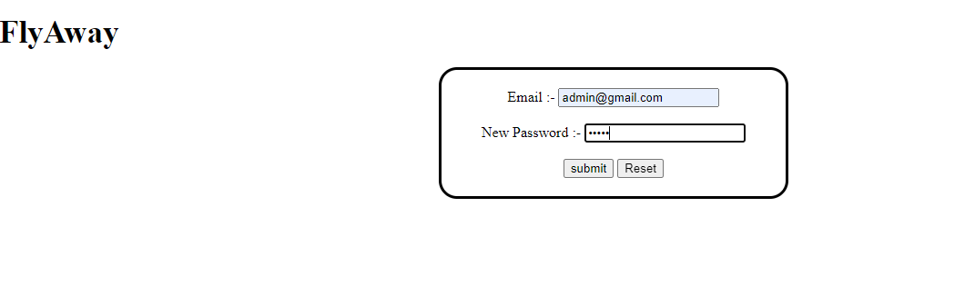change the password by entering email id.

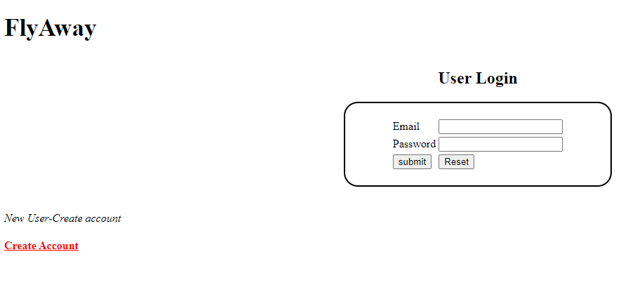

A new account can be created by clicking “Create Account”

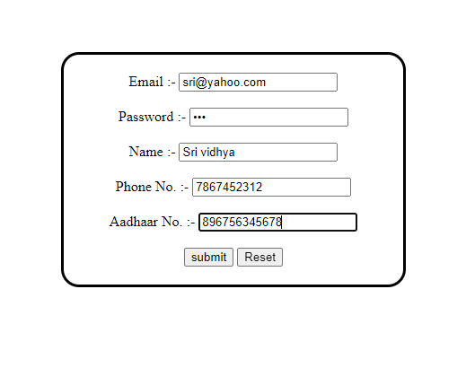

Enter the user details like email,password,name, phone number, aadhar number.

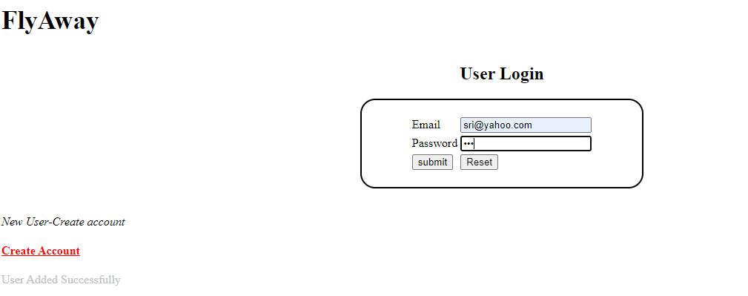

Then login using email and password

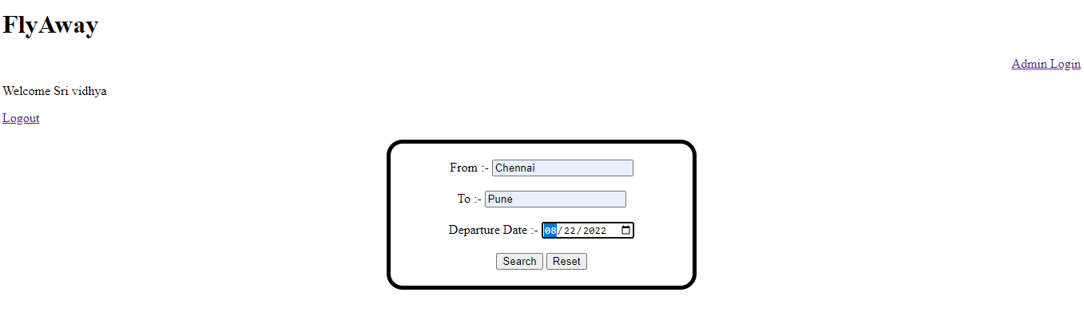

The above page is to select the booking date, source and destination

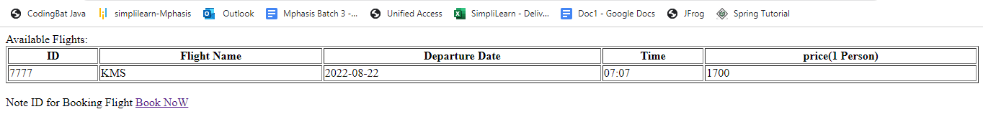

If that particular flight is available, then its details are displayed as table

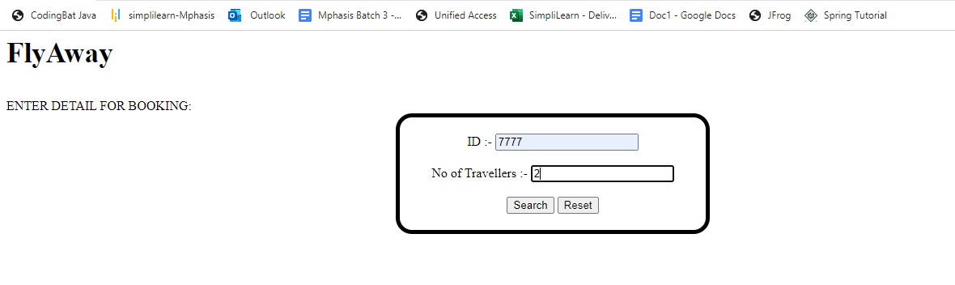

Then enter number of travellers

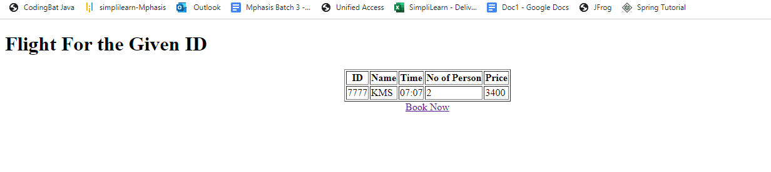

Then user can see the details of choosen data

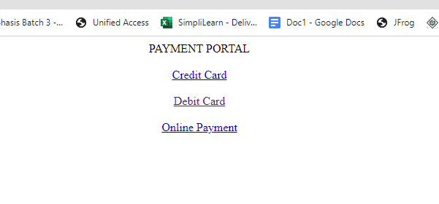

Then it prompts to Payment Portal

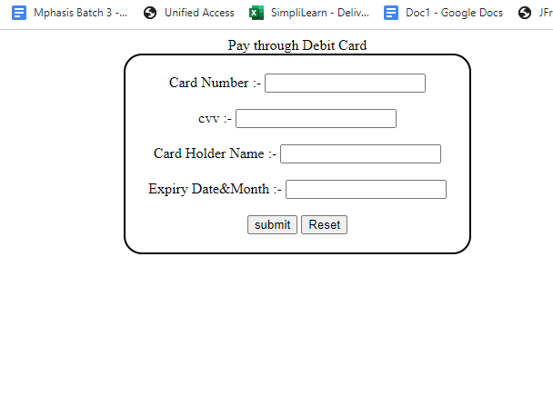

User can pay through Debit card or credit card or through upi

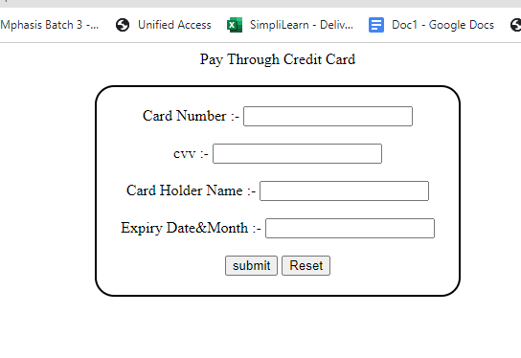

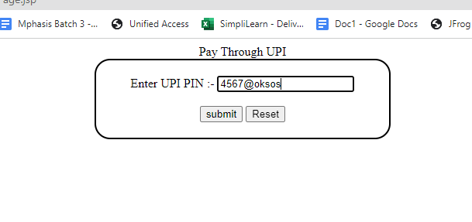

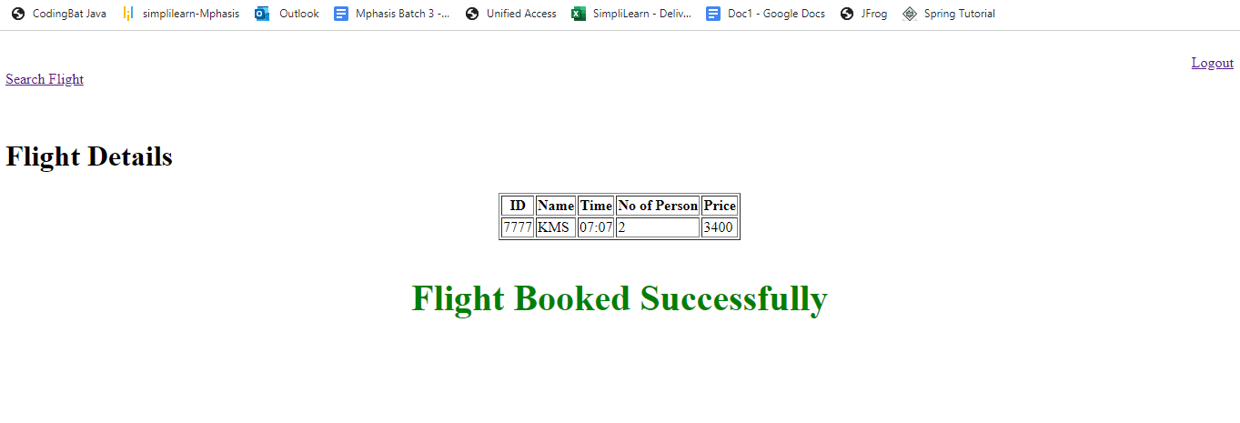

If payment is successful, it prompts to the above page.

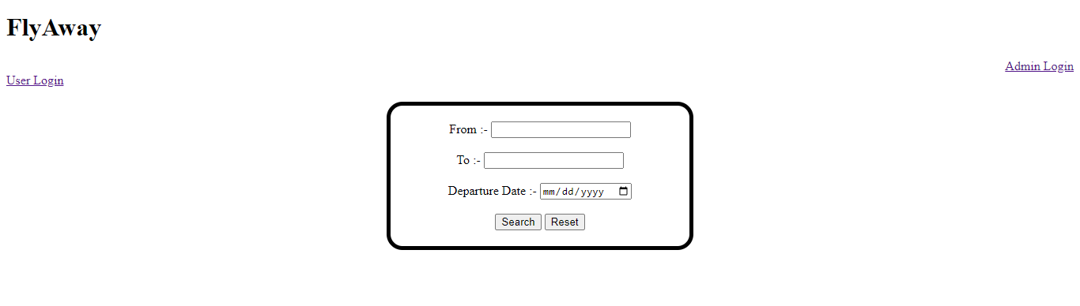

Then user can logout the portal by clicking on logout.

**MySQL**

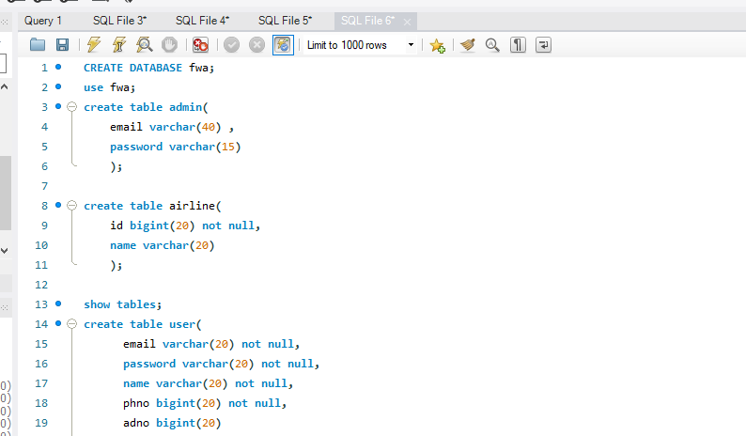

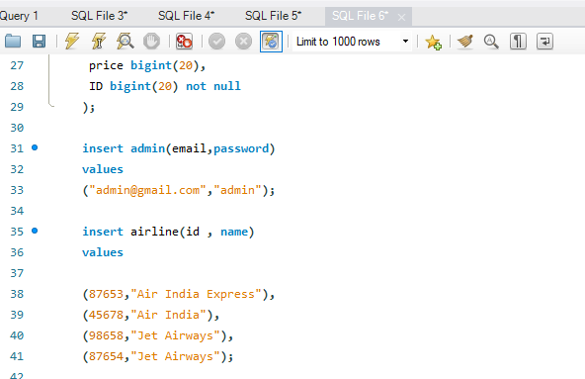

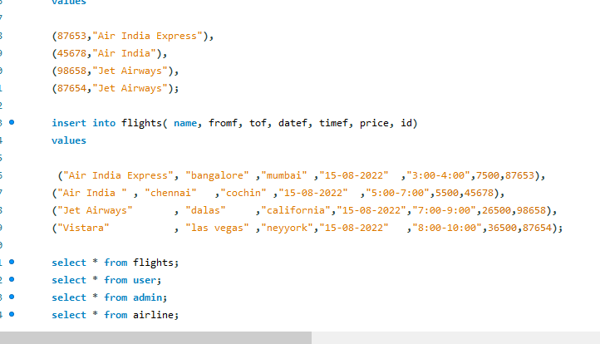

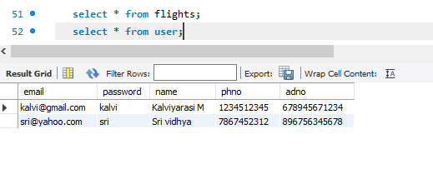

**We could see the new user “sri Vidhya” created in the above table**

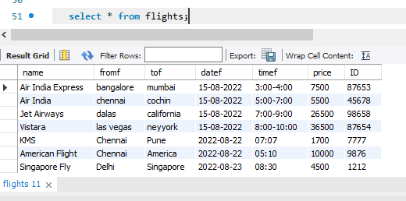

**Admin added new flight details, we could see data added in the database.**

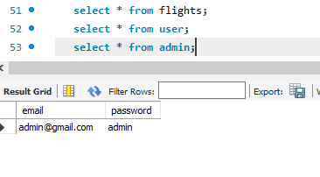

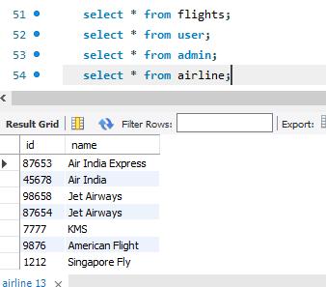

**We could see the airline added by admin in the above table.**